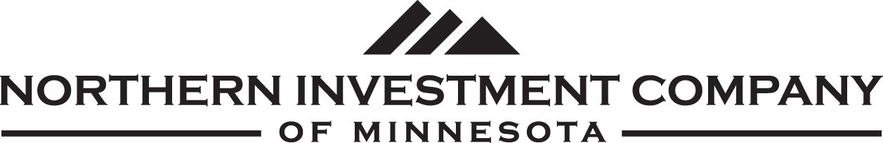

Pet Permit

Fill in the checklist below and return with a payment to accounting@nicprop.com This document will become part of your lease.

If you wish to add more pets or change the pets that you possess, please let us know at your earliest convenience.

Number of Dogs, K9 – (Any weight, indoor only) | $200.00 each
Number of Cats, Feline (Declawed only) | $200.00 each
Number of Birds (Birds not allowed at this time) | $000.00 each
Number of Reptiles (Reptiles not allowed at this time) | $000.00 each
Number of Amphibians(Amphibians not allowed at this time | $000.00 each
Fish tanks are allowed (Up to 55 gallon) No Charge | $000.00 each
Total amount of animals being permitted | $__________
Once you have been approved for your lease agreement, please fill out this form, sign it, and attach your check of payment in full with the images, and forward to:

Northern Investment Company of Minnesota
PO Box 466
Owatonna MN 55060

Accounting@nicprop.com

NOTE: Your lease agreement will not be completed without this document properly filled out and paid for. When your payment has cleared, a paid copy of this document will be returned to you for your records.

By signing this document I am aware that I am paying a one-time non-refundable pet deposit and assure that these will be the only pets that I will possess unless I inform Northern Investment Company of Minnesota before adding additional pets.

Pet Owner Signature:___________________________________________ Date:____________________

Office use only below this line

Payment received on :_________________ | Payment taken by:______________________________________
Permit validated on: _________________ | Stamp of Approval here: _________________________________

Document Version II-Pet Permit. Approved July 13th, 2022

